**環境建置 :**

1’Tomcat在- Luna Service Release 2 (4.4.2) 環境中

將The Apache Tomcat installation at this directory is version 8.5 to Tomcat 8.0

修改如下—在apache-tomcat-8.5.41\lib 找到 catalina.jar

打開org/apache/catalina/util/ServerInfo.properties

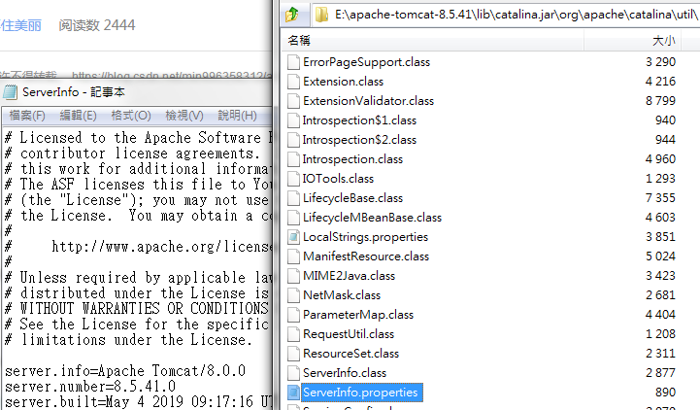

2’至官網下載 Binary

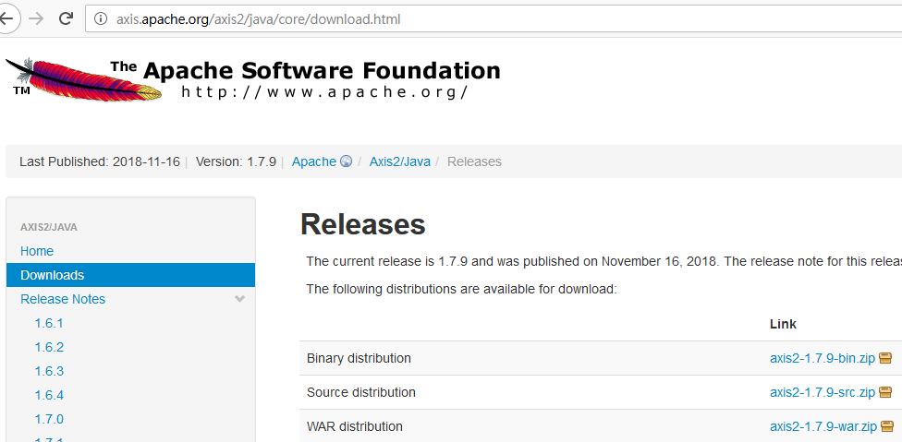

點 Web Service -> Axis2 Preferences ，在 Axis2 run time location這裡選擇 Axis2 Binary 的路徑

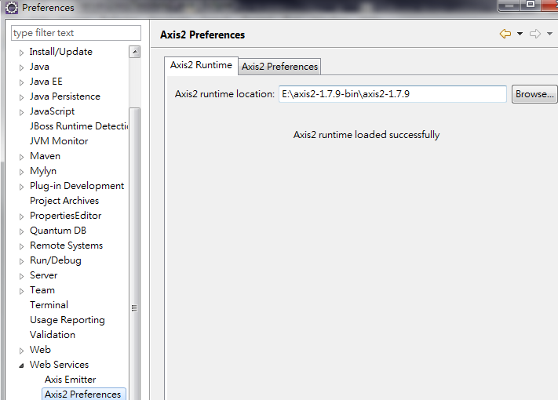

**Axis2 建立server side:**

0’ 建一個Dynamic Web Project 注意Dynamic web module version要選擇2.5或以下的版本 接著點 Modify 選擇 Axis2 Web Services ->完成

(P.S專案建好需在lib導入jstl.jar

下載 <http://apache.stu.edu.tw/ws/xmlschema/2.2.4/>

將xmlschema-core-2.2.4.jar 放置專案lib 並重啟tomcat)

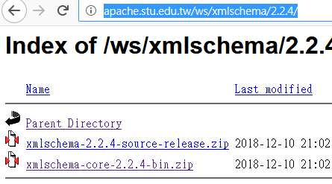

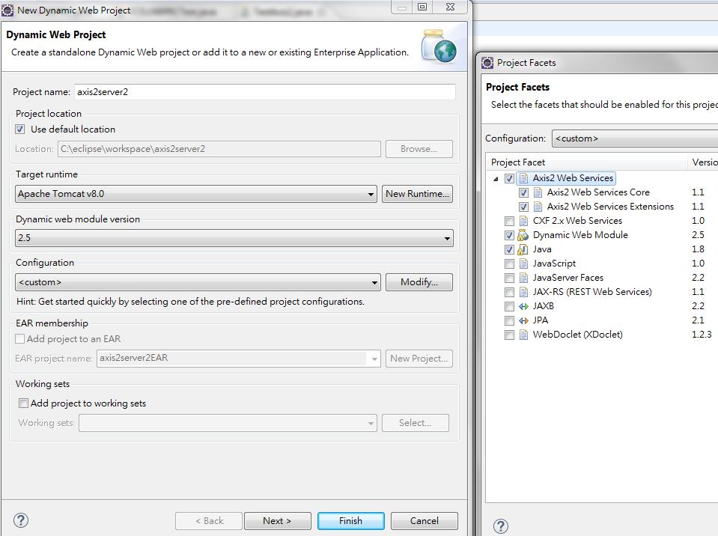

1’撰寫須建立的服務並將此專案加入至Tomcat 並開啟它

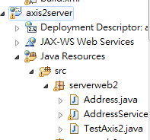

2’ 建立新的Web Service

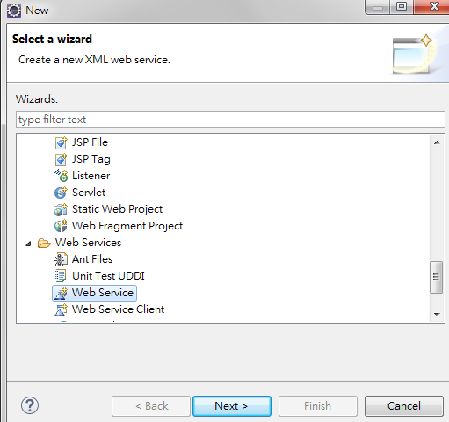

3’選擇要實現的服務和佈署配置

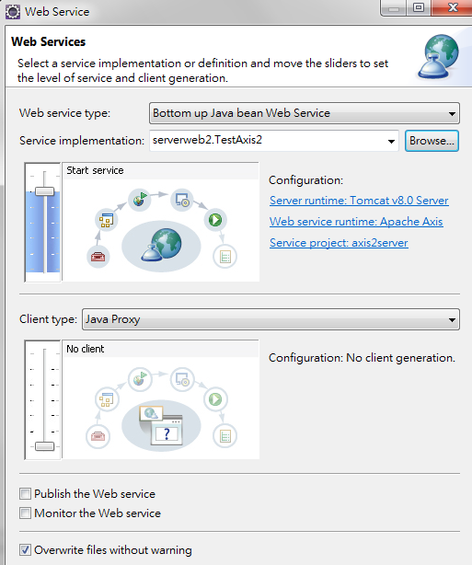

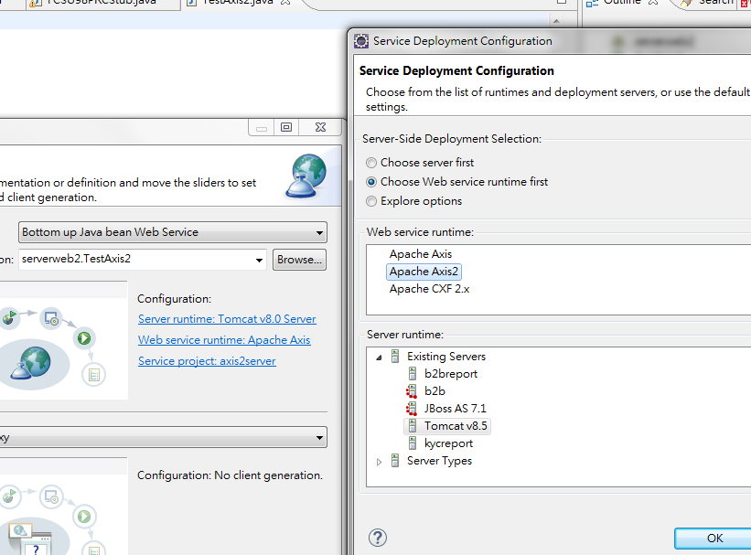

4’完成 產生對應的service.xml和.class

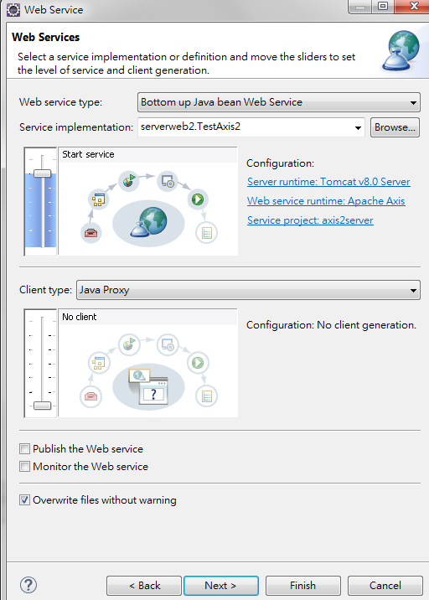

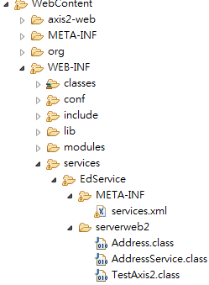

5’ service.xml -> 對應java中的方法名稱(不管裡面帶多少參數)添加option標籤

Ex TestAxis2.java

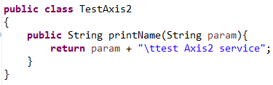

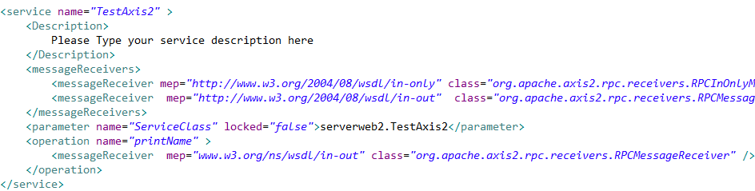

<operation name=*"printName"* >

<messageReceiver mep=*"www.w3.org/ns/wsdl/in-out"* class=*"org.apache.axis2.rpc.receivers.RPCMessageReceiver"* />

</operation>

**Axis2 建立client side:**

0’ 建一個Dynamic Web Project 注意Dynamic web module version要選擇2.5或以下的版本 接著點 Modify 選擇 Axis2 Web Services ->完成

(P.S專案建好需在lib導入jstl.jar

下載 <http://apache.stu.edu.tw/ws/xmlschema/2.2.4/>

將xmlschema-core-2.2.4.jar 放置專案lib)



1’複製wsdl 至對應的client side專案 點選右鍵新建web service client

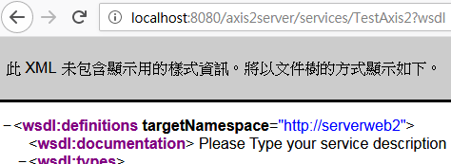

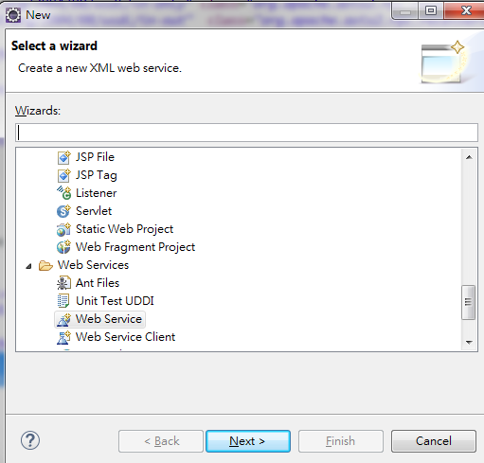

2’貼上wsdl ->選擇axis2 ->完成

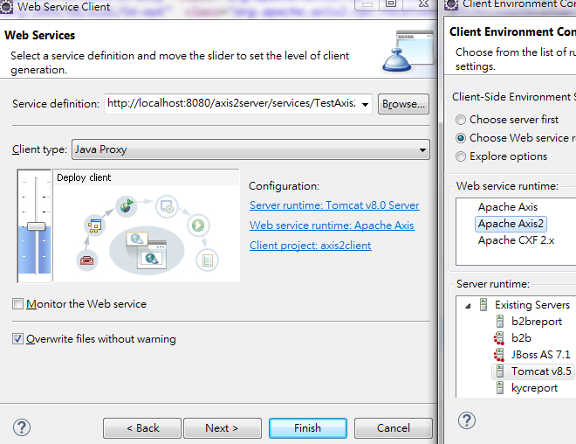

3’產生對應.java 測試於test資料夾中進行

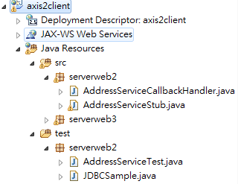

**參考資料:**

電子書:

https://epdf.tips/quickstart-apache-axis2.html

https://doc.lagout.org/programmation/tech_web/Apache/Apache%20Axis2%20Web%20Services%2C%202nd%20Edition.pdf

server & client環境建置

https://read01.com/zh-tw/kE7e75.html

http://programer-learn.blogspot.com/2011/10/axis2java-web-services_10.html

http://joeyta.blogspot.com/2006/07/apache-axis2java-web-service.html

錯誤訊息:

1' HTTP Status 500 — Servlet.init() for servlet AxisServlet threw exception 參考

https://medium.com/@PrakhashS/apache-axis-2-errors-and-exceptions-fdc4919197f2

2' The ServiceClass object does not implement the required method in the following form: OMElement login(OMElement e)

https://stackoverflow.com/questions/35720181/the-serviceclass-object-does-not-implement-the-required-method-in-the-following/37864267

https://blog.csdn.net/shenqiongniujiahui/article/details/51407682

3'The Apache Tomcat installation at this directory is version 8.5 to Tomcat 8.0

<https://blog.csdn.net/min996358312/article/details/69948397>